MAKING MATERIAL CHANGES

REQUESTING GCAS CODES FOR EO MATERIALS

Determine if you need new GCAS Codes for materials or parent rolls. If you need new codes, you will need to request them through CSS. To request new codes:

- Click ORIGINATOR – TECHNICAL STANDARDS.



- Click CREATE NEW STANDARD.

- A list will appear of all the current CSS Document Types. Choose Individual Raw Material Specification, then click ACTIONS – CREATE. (You will choose IRMS for both materials and parent rolls.)

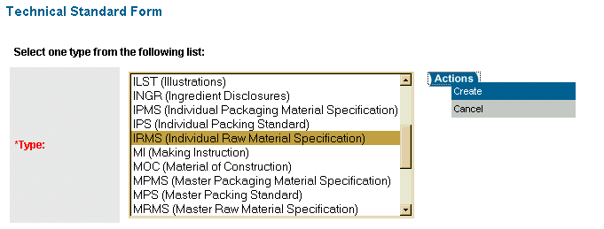

- The system will ask if you wish to create the technical standard with a document. If you are creating the material for EO purposes, you do not need a document at this point, so click CANCEL to create an IRMS (Material Only).

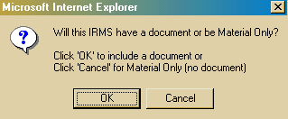

- A blank Technical Standard Form will open. Complete the required fields. Fields for an Individual Raw Material (such as an adhesive, or pulp) are:

DESCRIPTION | Follow the naming protocol for the material type. You can use a similar material in CSS as an example, or contact the Stds Office for the correct protocol.
SAP DESCRIPTION | This field will autofill if you hit TAB after entering the description. It is the first 40 characters of the Description field
OWNING ORGANIZATION | Select GLOBAL ~ TISSUES & TOWEL ~ *
OWNING SECTOR | Paper
OWNING STANDARDS OFFICE | GLOBAL-TT
LIFE CYCLE STATUS | PRODUCTION EXPERIMENTAL ORDER
MATERIAL GROUP | Dependent on material – examples are ADHESIVE, PULP, etc.
MATERIAL TYPE | RAW
MATERIAL FUNCTION GLOBAL | Dependent on the material – examples are adhesives, emulsifiers, strength additives
BASE UNIT OF MEASURE | Most materials are KG
PLANTS | Choose the plant(s) you need for the EO
CAS NUMBER | Choose CONFIDENTIAL

Fields for a Parent Roll are:
DESCRIPTION | Follow the naming protocol for parent rolls. You can use a similar material in CSS as an example, or contact the Stds Office for the correct protocol.
SAP DESCRIPTION | This field will autofill if you hit TAB after entering the description. It is the first 40 characters of the Description field
OWNING ORGANIZATION | Select GLOBAL ~ TISSUES & TOWEL ~ *
OWNING SECTOR | Paper
OWNING STANDARDS OFFICE | GLOBAL-TT
LIFE CYCLE STATUS | PRODUCTION EXPERIMENTAL ORDER
MATERIAL GROUP | Enter FINISHED PRODUCTS
MATERIAL TYPE | INTERMEDIATE MTL
MATERIAL SUB-TYPE | RAW MATERIAL MIXES
BASE UNIT OF MEASURE | Most materials are KG
PLANTS | Choose the plant(s) you need for the EO

- Once you’ve completed the fields, click ACTIONS – SAVE



You will now see that your material has a GCAS Number. However, to use the code at the plant, it must be approved and activated.

GETTING CODES ACTIVATED AND INTO SAP

- Once you have your GCAS codes, you need to route the Technical Standards Forms for approval so that they can be activated (this allows the plant(s) to see the codes in SAP and receive the materials). You do this by attaching them to a Change Request.

Click ORIGINATOR – CHANGE REQUESTS.



- Click CREATE NEW CHANGE REQUEST.

- A new Change Request Form will open. Some of the information, such as your name and phone number, will be filled in for you, other information will default to the information on your User Registration Form (such as your GBU and Owning Standards Office).

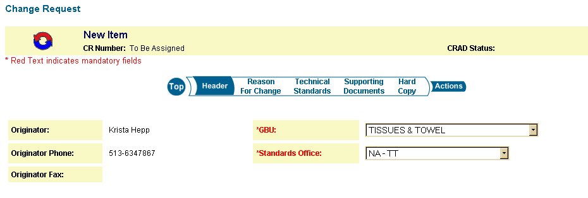

The following fields must be completed on the Change Request:
PRIMARY AFFECTED CATEGORY | Choose the category most affected by the EO (Toilet Tissue, Towel, Facial)
TITLE | Enter a title, such as “Tail Control Adhesive EO 6308”
DETAILED REASON FOR CHANGE | In this field, give a brief description of the change. Include the EO number

- You now need to attach the GCAS code(s) to the Change Request. Go to the Technical Standards section of the form.

You will see a list of draft Technical Standards displayed. In order for the standard to appear in this area, it must meet the following criteria:

- you must be the Originator or Co-Creator of the draft standard, AND
- the Technical Standard cannot be attached to any other Change Request

In order to add a Technical Standard, select the standard by checking the box marked “Add.”

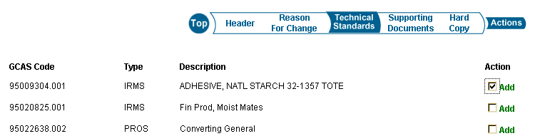

- Save your Change Request by clicking ACTIONS – SAVE. You will return to your Originator Change Requests area.



- Now you need to route your Change Request for approval. Because this is for an EO, only the Standards Office needs to sign off on the Change Request. To add the Standards Office as an approver:

From the ORIGINATOR – CHANGE REQUESTS area, select the Change Request, then CLICK ACTIONS – ADD/MODIFY APPROVER

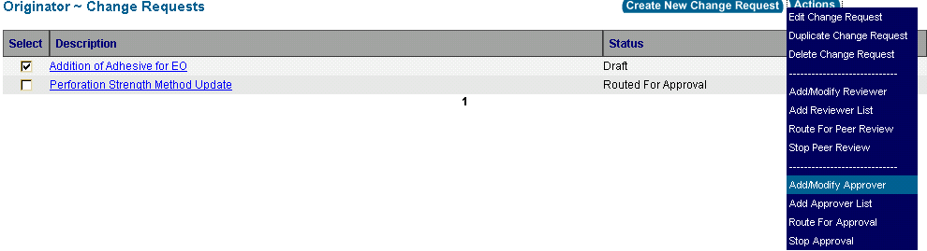

- You will see a screen that will let you add approver(s) as needed. Your screen will default to the Region and GBU that you belong to.
Enter the information for your approver. Make the approver step 1, then select the correct name from the list, and the approver’s role.

The Standards Office approvers are:

FACIAL – Vicki Bierman
TOILET TISSUE – Ann Kincer
TOWEL – Michele Fagin

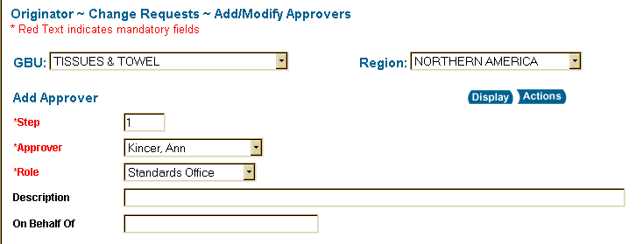

- Click ACTIONS – SAVE



- You will be returned to your ORIGINATOR – CHANGE REQUESTS area. You now need to route the Change Request for approval.

Select the Change Request, then click ACTIONS – ROUTE FOR APPROVAL.

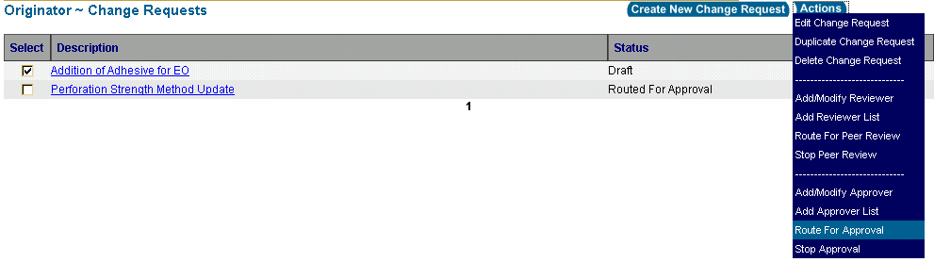

Enter a message to be sent to the approver, then click OK.

- Once the approver has completed their approval, you will receive an email with a link to your Change Request. Click on the link, then click ACTIONS – ROUTE TO SO. You will be required to enter your password.

At this point, you are finished with the work for the EO. You will receive an email saying that your materials were issued. The plant can expect to see the materials in SAP approximately 24 hours after the material is issued in CSS.
MOVING FROM EO TO PRODUCTION

Once your EO is complete, any materials that you have decided to use on an ongoing basis need to have specifications developed. These specifications must be in the Rows & Columns format. You can get a copy of the format by using a current spec in CSS, or by going to the MQS Extranet Template (Rows & Columns Material Template)

Now the specification has to be added to CSS:

- To do so, you will need to do a Copy to Revise on your GCAS Code(s). Enter the GCAS code in the GCAS Search Box at the top right of the screen, then click GO.



- Select the standard by checking the box. Then click ACTIONS – COPY TO REVISE.

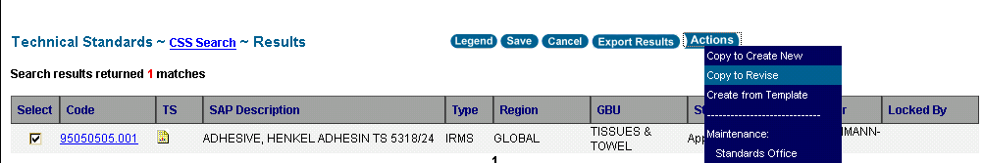

- A box will appear asking if you want to keep the Related Standards (links). Click OK.

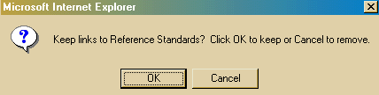

- The Technical Standard Form is now in Edit Mode. At this point, you need to attach the specification document. Do this by clicking on the BROWSE button. A file window will appear. Find the specification document on your computer, choose it, then click OPEN.

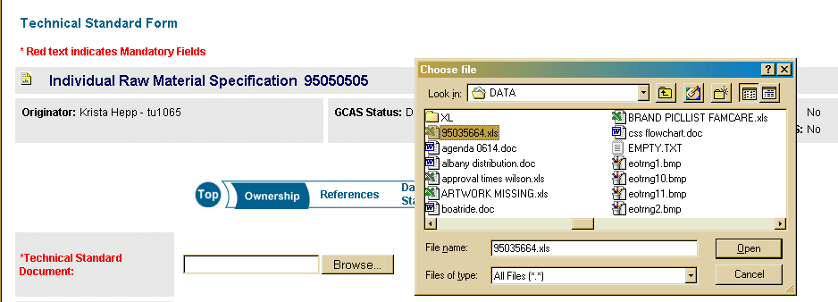

If there are any changes that need to be made on the Technical Standards Form (such as authorizing additional plants), you can do this now.

- Now click ACTIONS – SAVE. You will be returned to your Technical Standards area.

If there are additional changes that need to be made (such as to a Formula Card), you can follow the same steps.

CREATING A CHANGE REQUEST
Once all your changes are made, you will need to route the changes with a Change Request (SEE STEPS 1 THROUGH 5 IN GETTING CODES ACTIVATED AND INTO SAP)

SENDING THE CHANGE REQUEST FOR PEER REVIEW
Because the changes are no longer being made under an EO, there must be a review process. To send your Change Request for Peer Review:

- Go to ORIGINATOR – CHANGE REQUESTS. Select your Change Request, then click ACTIONS – ADD REVIEWER LIST.

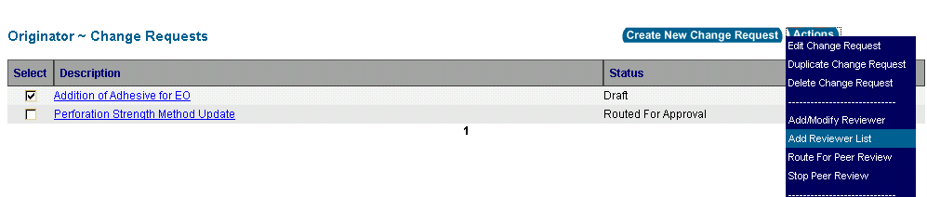

- You will then be able to choose which type of list you want to see, Personal or Standards Office. The Standards Office maintains all Peer Review lists centrally, so choose Standards Office.

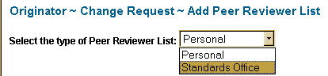

- Choose the region that you need, then click DISPLAY. All raw materials are global, all formula cards are regional.
- Select the list(s) you need to attach to your Change Request. You may need to attach more than one list (for example, if you are changing a raw material and a formula card). Then click ACTIONS – ATTACH.

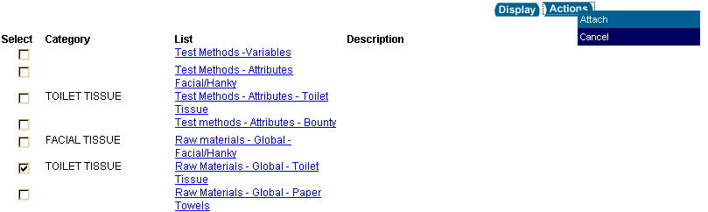

You will receive a confirmation that the list was added. Click OK. You will then be returned to your Change Request area where you can route the Change Request for review.

- Select the Change Request, then click ACTIONS – ROUTE FOR PEER REVIEW. Enter a message to the Reviewers, then click OK.

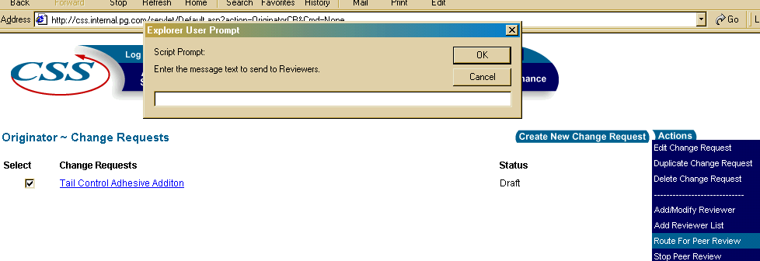

- Once you have sent the Change Request for Review, you can see comments that people have made. To view your comments, from the ORIGINATOR – CHANGE REQUESTS area, open your Change Request by clicking on the link, then go to ACTIONS – VIEW COMMENTS.

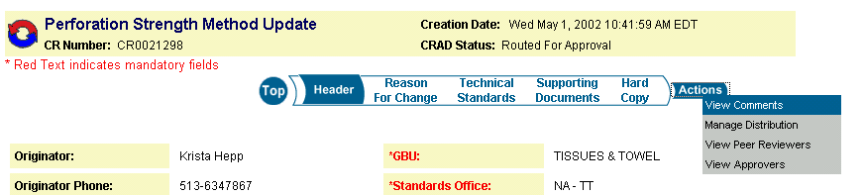

You will be able to see comments made on your Change Request, or on the individual standards. You can switch between the comments by clicking the radio buttons.

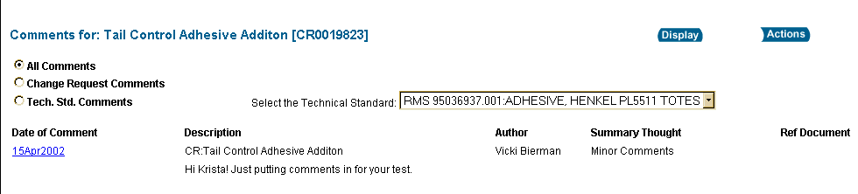

- Once review has been completed, you need to stop review. From your Change Request area, select your Change Request, then click ACTIONS – STOP PEER REVIEW. You will be able to enter a message to Reviewers, then click OK.

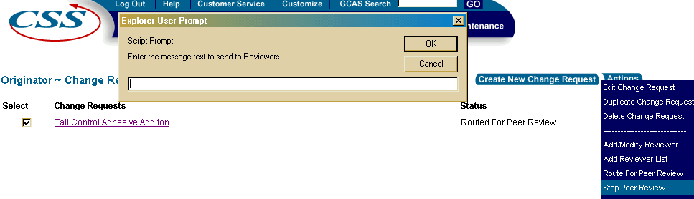

SENDING THE CHANGE REQUEST FOR APPROVAL
Once you have incorporated any changes into your standard(s), you will need to send the Change Request for approval. No changes can be made after the Change Request is routed without stopping approval and losing all signatures. The approvers are based upon the type of change, so in some cases there may be several approvers, and in others, only one. Contact the Standards Office to get the list of approvers appropriate for your change.

To add approvers:

- Go to your ORIGINATOR – CHANGE REQUESTS, select the Change Request, then click ACTIONS – ADD/MODIFY APPROVER.

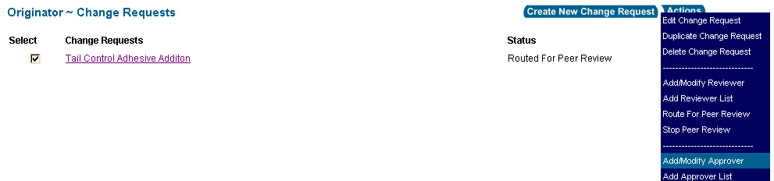

- Complete the fields as needed (all approvers should be Step 1):

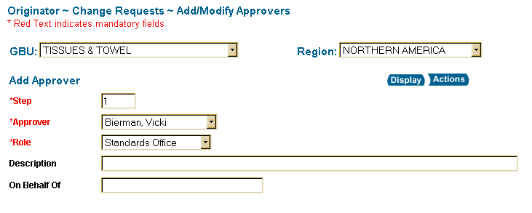

- After you add an approver, click ACTIONS - APPLY. This will allow you to continue adding approvers without returning to the Change Request.


- Once you have added all the appropriate approvers, click ACTIONS – SAVE. You will be returned to your Change Request area.

- You are now ready to route for approval. Select the Change Request, then click ACTIONS – ROUTE FOR APPROVAL. Enter a message to the approvers, then click OK.

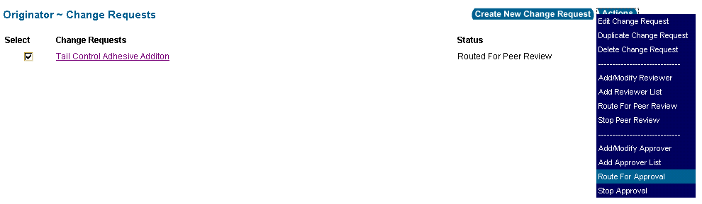

- Once all the approvers have approved, you will receive an email with a link to the Change Request. Open the link, then click ACTIONS – SEND TO SO. You will be required to enter your password.

- Once your changes have been approved by the Standards Office, the standard(s) will issue and you will receive notification via email. If any additional plants have been activated, they will be able to see the materials in SAP approximately 24 hours after issuance.

